**HOMEWORK**

**NAME:** CAROLINA GONZÁLEZ

**CLASS:** 3ro “B” ACCOUNTING

**DATE:** 30 OF APRIL OF 2015

**MUST USE**

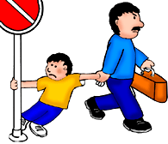It is used for debt

Affirmative

MUST + subject + infinitive + complement

I must do my homework

Negative

Subject + Must not / must not + infinitive + complement

I must not pee on the street

Interrogative

It is difficult to use and unusual, but you can:

Must + Subject + infinitive + complement

Must I open the door?

In this case it is better to use shall (will) or should

APPLICATIONS 

We use the modal verb must to express:

1. Obligation

The semi modal Have to also used to express obligation. The difference is that the obligation is expressed Have to external (is given by a third party or by rules) while the obligation is expressed must imposed by the speaker or the writer the phrase. Furthermore, the obligation must have future intention.

I must write an e-mail to my cousin (I write an e-mail to my cousin) →'s something that I impose myself. I still have not, have future intention.

Their passengers must fasten seatbealts (passengers must wear a seatbelt) → It is something that requires the company that wrote the sentence.

I have to wear uniform at work (I have to wear a uniform at work) → is something imposed on me at work.

2. Moral Duty

You must respect your parents (you must respect your parents)

3. Council (persuasion)

This is very important to distinguish the "should" is also used to express advice. We must use to express strong recommendation, or advice, to the point of wanting to persuade the interlocutor.

You must go and see That film (You must go and see that movie)

You must clean your car (you should clean the car)

4. Strong Need

Here we must distinguish the semi-modal Have to also express need. Must is used to express a strong need.

I must tidy my bedroom. It's a mess (I ordered my room. It is a mess)

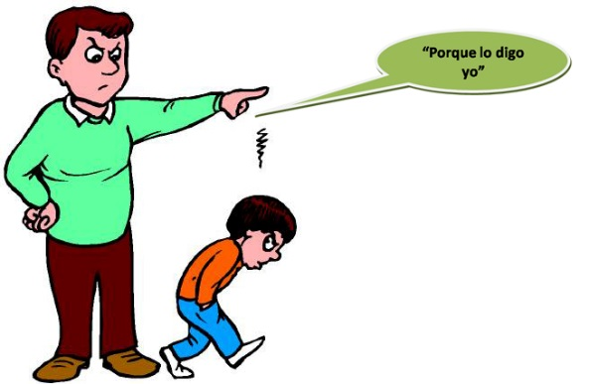In addition, we use only must to express a strong need for this. If we use other tenses, we resort to have to.

I'll Have to go to the doctor (I'll have to go to the doctor) → future

I had to leave early (I had to leave early) → last

5. Affirmative deduction.

You got up very early. You must be tired (you got up very early. You must be tired)

The lights are on. She must be home. (The lights are on. It should be at home)

For negative deductions will use the modal cannot.

You cannot be 30! You look younger. (You cannot have 30 years! You look younger)